Amnesty South West England Network Webinar

Thursday 21 May at 7.30 pm

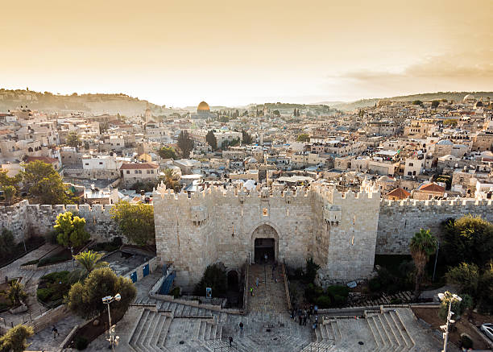

A political solution to the Palestine/ Israel situation
The One Democratic State Initiative (ODSI)

It is now widely acknowledged that the Two State Solution to the Israel/ Palestine conflict is unworkable. So, the ODSI takes an alternative view, as a Palestinian-led initiative that aims to take “identity” out of the debate and to instead focus on establishing one democratic state “for all citizens, from the river to the sea”. A state that is democratic, secular and socially just, in which Palestinians and Israeli Jews live in equality. This is the antithesis of the Zionist colonial/ settler project.

This talk, by Liam, a coordinator with the ODSI, will look at the reasons it is important to look at a political solution, how it can answer key questions and how it can become a reality.

This webinar is very timely as 15 May is Nakba ( catastrophe ) Day, commemorated annually to mark the beginning of the destruction of the Palestinian homeland and the mass displacement in 1948 of the majority of the Palestinian population.

Please register for this free event on Zoom by clicking the link below:

https://us06web.zoom.us/meeting/register/xDyK8PqfToCZPFfeGGprgg

To find out more about the new SW Network, please email us at aswenetwork21@gmail.com

